HomeBlogGSDReact Best Practices: Maintaining Large Scale Projects

React Best Practices: Maintaining Large Scale Projects

Zain Sajjad
Published on
Updated on
13 min read

GSD

Table of contents
- Why use React?
- Why should you maintain your React application?
- What could happen if you fail to maintain your React application?
- React maintenance best practices
- Frequently Asked Questions (FAQs) about big React projects
- Final words
Post updated by Maab Saleem.
“The real cost of software is maintenance over time because change is inevitable”
As developers, it's important to aim for low-maintenance apps that are built using coding best practices and have well-defined, modular architectures. Such apps not only require less ongoing effort but also perform and scale better.
Contrary to popular belief, it's possible to design large-scale projects to be low-maintenance, even those that use numerous third-party components, such as React-based front-end apps. Modern front-ends have become increasingly complex, with everything from distributed computing platforms to interactive Big Data dashboards being built on the web.
With the rise of advanced browser-based technologies, like Progressive Web Apps (PWAs), developers must grapple with an ever-expanding array of tools, each with their own quirks and idiosyncrasies. As a result, managing dependencies, ensuring compatibility, resolving technical debt, and maintaining code quality can be a daunting task.
The cost of maintenance and the time needed to develop new features increase as the complexity of an application grows. However, by adhering to certain best practices and design principles, you can simplify your job as a developer.
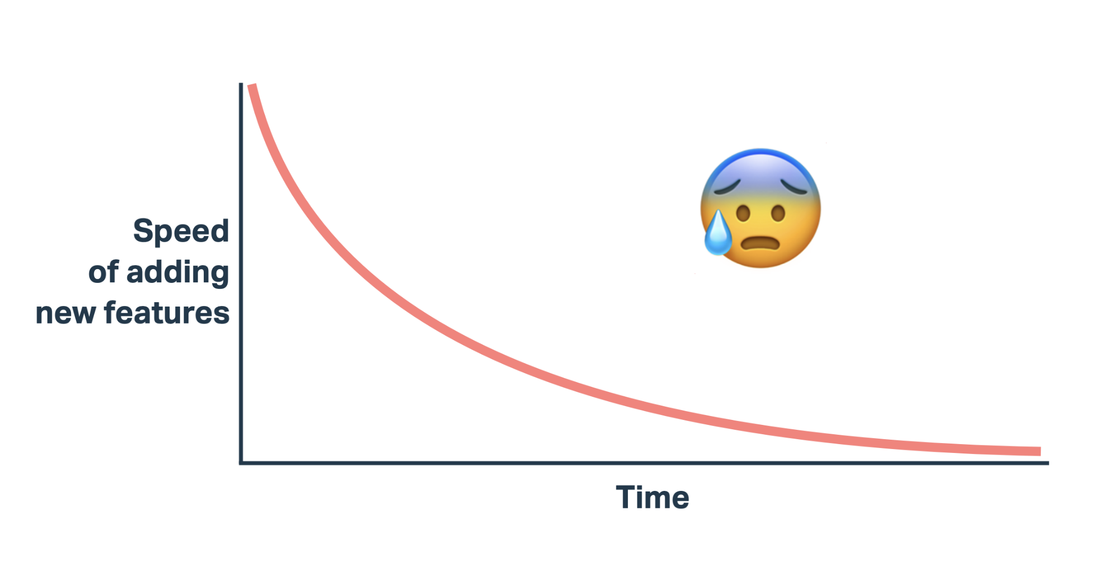
In the following post, we'll outline some guiding principles for building large-scale React projects that are low-maintenance, so that you can focus on adding new features and improving functionality.

Why use React?
React is a powerful front-end library that fast-tracks the development of feature-rich web applications. It’s flexible, enabling developers to cater to a wide range of use-cases, such as generating static sites, performing server-side rendering, and building cross-platform mobile applications (using React Native).
Here are a few more reasons to use React:

A framework for everything
There are numerous frameworks and tools built on top of React, each with a unique set of features catering to specific use cases. Developers can select the one that best fits their requirements and start building their applications quickly.
For instance, when building a website with predominantly static content, you can choose Gatsby. If the website is anticipated to have a substantial amount of dynamic content, you can go with Next.js. If you want a custom routing solution for your React app, you can simply install React Router.

Efficient rendering
React utilizes a virtual Document Object Model (DOM) to efficiently manage updates and rendering of components. The Virtual DOM is a lightweight copy of the actual DOM, a tree-like structure that represents the HTML elements of a web page.
When changes are made to a component, React updates the virtual DOM instead of the actual DOM. By doing so, it minimizes the number of required DOM manipulations, resulting in faster rendering and better performance.

Concurrency
React 18 comes with built-in concurrency. Concurrent React enables developers to prioritize rendering operations. For example, you can pause a non-urgent rendering task to perform a high-priority rendering operation, without affecting the consistency of the UI. This leads to an engaging and intuitive front-end that is always ready to respond to user input.
Learn how to build reusable React components - essential for large-scale projects.
Read tutorial

Developer friendliness
React's simple and intuitive syntax, along with its robust set of development tools, makes it easy for developers to build and maintain layered web applications. Its component-based architecture allows for the creation of reusable UI components, making development faster and more productive.

Cross-platform compatibility
React, through React Native, empowers developers to build applications for the web, iOS, Android, and other platforms with a single, unified codebase. This significantly reduces the time and effort required for cross-platform development. React Native also provides platform-specific components and APIs to develop responsive and performant mobile applications.

Why should you maintain your React application?
Like any other software project, React applications need ongoing maintenance for several reasons.

Bug fixing
Bugs are an inevitable part of any software project, whether it is well-designed or poorly-designed. However, the frequency of bugs is much lower in well-designed, low-maintenance software projects. Maintaining your React application ensures that any bugs or issues that arise can be addressed and fixed in a timely manner.

React changes frequently
The React library changes frequently, with new features and improvements being added on a regular basis. To ensure that your application is as performant as possible, you need to stay up-to-date with these changes. For example, React 18 offers various features to boost performance and responsiveness.
Moreover, React projects often rely heavily on third-party packages for many functionalities, like routing, state management, and styling. Part of the regular maintenance involves making sure that these packages are up-to-date and do not contain any known security vulnerabilities.

Scalability
React applications that are architected with scalability in mind may not require periodic maintenance to ensure they can handle increased traffic and demand. However, for projects that are complex and poorly designed, periodic maintenance is necessary to make the application scalable.
This involves optimizing the codebase, refactoring as needed, and updating third-party packages to boost application performance and throughput.

Resolving technical debt
Low-maintenance software projects often don't have to deal with technical debt. However, if your project is full of hacks, workarounds, and doesn't adhere to coding best practices, then maintaining it can become a significant challenge. In such cases, a considerable portion of your maintenance efforts may have to be spent on fixing technical debt.

What could happen if you fail to maintain your React application?
Failing to maintain a React application can have several damaging consequences for your business.
- Poor application security: Regularly assessing your source code for vulnerabilities and bugs is essential to prevent security threats, such as cross-site scripting and zero-day exploits. This is particularly important if you are utilizing numerous third-party, open-source components.
- Diminishing quality and performance: Skipping maintenance can result in accumulation of excessive technical debt. This, in turn, can cause the application's performance to degrade, leading to slow load times and an unresponsive user interface. These issues can frustrate users and they may abandon the application altogether.
- Compatibility issues: Regular maintenance of your React application includes updating both the React core and external components. Failure to do so may lead to compatibility issues when using external libraries or frameworks that require a newer version of React. In some cases, these libraries may no longer support older versions of React, causing conflicts and errors in your application.
- Reduced speed to market: Poor maintenance hygiene can lead to a buildup of technical debt, bugs, vulnerabilities, and complexity. This, in turn, can significantly hamper developers' ability to add new features to the codebase, and reduce your speed to market.

React maintenance best practices
The following best practices apply to both building scalable, low-maintenance React apps from scratch and maintaining complicated existing ones.

Keep components organized
As your React application grows, it can become challenging to keep track of all the components and their interdependencies. Organizing components in a clear and logical way can help avoid this problem.
For example, you may create a component hierarchy, group related components together, and give them descriptive and consistent names. By keeping your components organized, you can make it easier to maintain and update your application over time.
You can quickly locate and modify specific components without having to search through a large codebase or decipher complex interdependencies. This will save time and reduce the risk of introducing bugs or breaking existing functionalities. Furthermore, it will also allow other developers to easily understand your code and contribute to the project.

Govern the use of wrapper components
Wrapper components serve as an abstraction layer between your application and APIs of third-party components. They allow you to decouple your application's code from the specifics of the API, making it easier to swap out different APIs in the future, if necessary.
For example, suppose you're building a React application that integrates with a third-party authentication service, such as Auth0. Instead of directly using the Auth0 SDK in your components, you could create a wrapper component that abstracts away the details of the authentication process.
This wrapper component could handle the authentication flow, store the authentication state in its own state, and pass down that state to its children components through props. This way, you can use the wrapper component in multiple parts of your application without having to duplicate the authentication logic. In the future, if you decide to switch to a different authentication service, you can easily update the wrapper component without making changes elsewhere in your codebase.
Although wrapper components can offer value in some scenarios, their excessive use can lead to a bloated component hierarchy that can be difficult to maintain and modify. Therefore, they should be used judiciously and only when they are necessary and applicable to the use case.
Learn how to build reusable React components - essential for large-scale projects.
Read tutorial

Make uniform React components
To ensure that your React application is easy to maintain and develop, it's important to establish clear naming conventions and use consistent design patterns throughout the codebase. Uniformity across components allows multiple developers to work on one or more features simultaneously, and for new developers to join the project without having to navigate through a large amount of code.
For example, you may define a guideline for creating a component directory. Each component may have a file structure that includes a main file for the component logic, a separate file for the styling, and a test file for unit testing.

Simplify your React testing
To make your React project be low-maintenance, it's important to prioritize improving the testability of your source code. The easier it is to test different components, the lower the chances of encountering bugs, vulnerabilities, and broken features.
One way to simplify testing is by adopting test-driven development, a technique in which you write unit tests for your features, before writing the actual code. Tools like Jest and React Testing Library can be used to build a powerful, test-driven environment for your React application.
Another best practice is to use testing utilities and helpers to reduce the amount of code needed to set up and perform tests. For example, you can use the "render" method from the React Testing Library to test rendered elements for specific behavior or UI changes. The following test validates that the “App” component renders and includes a link with text "Learn React".
import { render, screen } from '@testing-library/react';
import App from './App';

test('renders the App component', () => {
render(<App />);
const linkElement = screen.getByText(/learn react/i);
expect(linkElement).toBeInTheDocument();
});

Write portable components and promote code reuse
Write portable components that can be easily reused in different parts of the application or in future projects. Make components self-contained, with minimal dependencies on other parts of the application. Use props to pass data wherever necessary.
This approach makes it easier to refactor or migrate the application, and reduces the risk of breaking existing features while adding new ones. Additionally, use shared functions to reduce duplication and promote reusability.
For example, if multiple components need to fetch data from APIs, you could create a shared function that takes in a URL, and returns a promise that resolves with the fetched data.
function fetchData(url) {
return fetch(url).then((response) => response.json());
}
export default fetchData;
The function can then be imported and used in any component that requires data fetching.
import React, { useState, useEffect } from "react";
import fetchData from "./fetchData";

function MyComponent() {
const [data, setData] = useState([]);

useEffect(() => {
fetchData("https://myapi.com/data").then((data) => setData(data));
}, []);

return <div>{/* render the fetched data */}</div>;
}

export default MyComponent;

Follow CI/CD practices
Incorporating Continuous Integration and Continuous Delivery (CI/CD) into your software development lifecycle reduces the maintenance efforts required for your React app. CI/CD workflows automate the testing, building, and deployment of code changes, from the developer machine to production.
This minimizes the likelihood of errors and broken features, and improves the speed of delivering new features to your customers. For example, you can set up a production pipeline that performs the following steps:
- For every new pull request, generate a build, and perform static code analysis on it.
- Execute a vulnerability scanner to check for any known exploits.
- Run the test suite.
- If the above 3 steps succeed, merge the code to the master branch.
- Once code is successfully merged, package and ship it to the production server.

Frequently Asked Questions (FAQs) about big React projects

What aspects of React make it hard to maintain?
React’s rapid evolution and flexible nature can make it challenging to maintain. The introduction of new features and paradigms, such as concurrency in React 18, can require developers to adapt and learn quickly.
React projects often use several third-party libraries, each with their own updates and compatibility issues. These libraries can sometimes conflict with each other, leading to bugs and inconsistencies in the code.
Moreover, too many external dependencies can make it difficult to keep track of all the different components, state, and data flow. This can result in spaghetti code and a tangled web of dependencies that can be hard to debug and maintain.
To overcome these challenges, it’s important to follow best practices, like: establishing clear guidelines for code structure, using automated testing and continuous integration, and staying up-to-date with the latest advancements in the React ecosystem.

How to reduce the cost of maintaining a react application?
Following some coding best practices and design principles can significantly decrease the cost of maintaining a React project.
- Write clean, maintainable code that scales well by design. Create well-organized, portable modules, reduce code duplication via helper functions, and document extensively. These practices reduce code complexity, and the chances of errors.
- Adopt test-driven development, and use continuous integration to catch errors early in the development cycle. This will decrease technical debt, and reduce the overall cost of maintenance.
- Keep the application up-to-date with the latest version of React and its dependencies. This will help you avoid compatibility issues and vulnerabilities.
- Validate the need for a third-party component before integrating it into your project. This will help in minimizing the overall maintenance footprint.

Final word
React is a well-maintained, robust JavaScript library powering millions of applications worldwide. It’s easy-to-use, has several powerful frameworks, offers different techniques for both static and dynamic rendering, and boasts exceptional performance and scalability. This post aimed to provide guidance on maintaining large-scale React projects by outlining key principles. We hope you found it helpful.
Learn more about React & how to use it with a headless cms in the following tutorials:
- Best React Component Libraries to develop a multilingual app
- What is Serverless and How to Use it in Practice
- How to Build a Blog with React and ButterCMS
- How to Build a React Portfolio Website

Author
Zain Sajjad
Zain is a Senior Frontend Engineer at Peekaboo Guru. He is passionate about anything and everything React, React Native, JavaScript & Mobile Machine Learning.

Related Posts & Resources
Explore more helpful content to build your best site!
View all resources

GSD

Angular SEO: How to Make Search-Friendly Pages

Maab Saleem
Read more

GSD

5 of the Best Static Website Hosting Services

Bonnie Thompson
Read more

New to Headless CMS? Check out our Guide!
Get a step-by-step walkthrough of how to determine whether Headless CMS is a good option for your team and what to do next to enjoy the benefits!

* Email
Get My Guide
By subscribing you agree to our Privacy Policy.

Product
Headless CMSCapabilitiesFeaturesIntegrationsAPI
Developers
Knowledge BaseDeveloper DocsAPI DocumentationDeveloper HubStarter ProjectsAPI Status
Explore
PricingPartnersSecurityCareersContact Us
Resources
BlogPodcastWordPress AlternativeContentful AlternativeMedium AlternativeStrapi Alternative

